#### A

#### PROJECT STAGE -I REPORT ON

**“A GEO-INTELLIGENT CROP ADVISOR AND MARKET PREDICTOR SYSTEM FOR FARMERS”**

SUBMITTED TO SAVITRIBAI PHULE PUNE UNIVERISTY FOR THE PARTIAL FULFILLMENT OF THE REQUIREMENTS FOR THE DEGREE OF

**BACHELOR OF ENGINEERING IN**

**ELECTRONICS AND TELECOMMUNICATION**

Submitted by

##### ANUSHRAY NITIN PANGALE (Exam No. B190073119) ADITYA VILAS CHAVAN (Exam No. B190073025) TEJAS GOPAL KULKARNI (Exam No. B190073084) DARSHAN VIJAY PAKHALE (Exam No. B190073108)

Under the Guidance of

##### Prof. A. S. Najan



**Department of Electronics and Telecommunication Engineering**

**Pune Vidyarthi Griha’s College of Engineering and Technology & G K Pate(Wani) Institute of Management, Pune -411009**

Academic Year 2023-2024

**Undertaking**

We, the students of Department of Electronics and Telecommunication Engineering, PVG’s College of Engineering and Technology & G K Pate(Wani) Institute of Management, Parvati,

Pune-411009

|  |  |  |
| --- | --- | --- |
| 1. Anushray Nitin Pingale | Exam Seat No.- B190073119 |  |
| 2. Aditya Vilas Chavan | Exam Seat No.- B190073025 |  |
| 3. Tejas Gopal Kulkarni | Exam Seat No.- B190073084 |  |
| 4. Darshan Vijay Pakhale | Exam Seat No.- B190073108 |  |

do hereby undertake on 25.10.2023 the following:

##### We are aware of the University Grants Commission (Promotion Of Academic Integrity and Prevention of Plagiarism In Higher Educational Institutions) Regulations, 2018 and Plagiarism Policy of Savitribai Phule Pune University Pune,

1. We are also aware that **Department of Electronics and Telecommunication Engineering, PVG’s College of Engineering and Technology & G K Pate(Wani) Institute of Management, Parvati, Pune** has established **Departmental Academic Integrity Panel (DAIP)** as per **UGC regulations 2018** as mentioned above in (1),
2. We are aware of the consequences if found guilty of doing any act of plagiarism defined in the UGC regulations 2018 as mentioned above in (1),
3. We shall abide by the rules, regulations and code of conducts for the students of UGC, SPPU and Department of E&TC,
4. We further undertake and declare that the thesis submitted by us is scanned using anti- plagiarism software as decided by the department and report of the same has been submitted and is free from any kind of plagiarism mentioned above (1) in **UGC REGULATIONS, 2018,**

##### I understand that non-compliance of the Academic Integrity and Prevention of Plagiarism may results in disciplinary action on us as per the University Grants Commission (Promotion of Academic Integrity and Prevention of Plagiarism in Higher Educational Institutions) Regulations, 2018.



**Department of Electronics and Telecommunication Engineering**

**Pune Vidyarthi Griha’s College of Engineering and Technology & G K Pate(Wani) Institute of Management, Pune -411009**

**CERTIFICATE**

This is to certify that the project entitled, **“A Geo-Intelligent Crop Advisor and Market Predictor System for Farmers”, is a work of**

1. Anushray Nitin Pingale Exam Seat No.- B190073119
2. Aditya Vilas Chavan Exam Seat No.- B190073025
3. Tejas Gopal Kulkarni Exam Seat No.- B190073084
4. Darshan Vijay Pakhale Exam Seat No.- B190073108

towards the partial fulfillment of the degree of **Bachelor of Engineering** in **Electronics and Telecommunication** Engineering to be awarded by the **Savitribai Phule Pune University, Pune** at **Pune Vidyarthi Griha’s College of Engineering and Technology & G K Pate (Wani) Institute of Management, Pune** during the academic year 2022-2023.

|  |  |  |
| --- | --- | --- |
| (Prof. A. S. Najan) | (Prof. Dr. Y. B. Thakare) | (Dr. M. R. Tarambale) |
| Project Guide | Head, Department of E &TC | Principal |

Place: Pune Date:

**ACKNOWLEDGEMENT**

It gives us great pleasure to present the preliminary project report on **‘A Geo-Intelligent Crop Advisor and Market Predictor System for Farmers’**.

We would like to take this opportunity to thank our guide Prof. A. S. Najan for giving us all the help and guidance we needed. We are grateful to him for his kind support. His valuable suggestions were very helpful.

We are also grateful to the **Head of Department, Dr Y. B. Thakare**, Electronics and Telecommunication Department, Pune Vidyarthi Griha’s College of Engineering and Technology & G K Pate(Wani) Institute of Management for her indispensable support and suggestions.

##### ANUSHRAY NITIN PANGALE (Exam No. B190073119) ADITYA VILAS CHAVAN (Exam No. B190073025) TEJAS GOPAL KULKARNI (Exam No. B190073084) DARSHAN VIJAY PAKHALE (Exam No. B190073108)

**ABSTRACT**

It is a web-based application which is helpful for farmers. Over the most recent couple of many years’ analysts are keen ashore planning and its arrangement for different reasons. The intention behind the expansion of is that soil strength is fundamental, so growing interest in farmland and soil condition research is fundamental to solid yield generation. The image sequence is one of his methods of studying soil and land health. It’s an amazing way to take into account the influence of different components. This paper proposes the investigation of flow and explores the issues it tends to and its possibilities. The focus is on a logical analysis of numerous cutting-edge grouping systems and techniques. To improve the precision of these methodologies’ characterization, an attempt was made to look at the factors that gave rise to them. In general, choosing the optimal classifier and making proper use of a set of remotely collected information highlights are crucial for enhancing grouping accuracy. For combining data from many sources, nonparametric classifiers like information-based arrays or neural networks have lately gained popularity. Although not without status, there is still room for further research to eliminate flaws and enhance the accuracy of image grouping tools. A random forest algorithm is used to suggest crops based on soils. Also, we are predicting the PH, rainfall and temperature using KNN we are recommending the shop to user.

**Contents**

|  |  |
| --- | --- |
| **List of Figures** | **v** |
| **List of Tables** | **vi** |
| **1 INTRODUCTION** | **1** |
| 1.1 Overview ………………………………………………………………... | 2 |
| 1.2 Motivation …………………………………………………………… | 2 |
| 1.3 Objectives ……………………………………………………………….. | 3 |
| 1.4 Outcomes ………………………………………………………………... | 3 |
| 1.5 Organization of the Report ………………………………………………. | 3 |
| **2 LITERATURE SURVEY** | **4** |
| **3 DESIGN OF THE PROPOSED SYSTEM** | **7** |
| 3.1 Block Diagram of the System ……………………………………….. | 8 |
| 3.2 ASSUMPTIONS AND DEPENDENCIES ………………………… | 8 |
| 3.3 FUNCTIONAL REQUIREMENTS ……………………………………. | 9 |
| 3.3.1 System Feature 1(Functional Requirement) ………………….... | 9 |
| 3.3.2 System Feature2 (Functional Requirement) …………………… | 9 |
| 3.4 EXTERNAL INTERFACE REQUIREMENTS ……………………….... | 9 |
| 3.4.1 User Interfaces ……….……......................................................... | 9 |
| 3.4.2 Hardware Interfaces ….…………………………………………. | 9 |
| 3.4.3 Software Interfaces …………………………………………….. | 9 |
| 3.4.4 Communication Interfaces ……….…….……………………….. | 10 |
| 3.5 Nonfunctional Requirements …………………………………………... | 10 |
| 3.5.1 Performance Requirements ………………………………… | 10 |
| 3.5.2 Safety Requirements…………………………………………… | 10 |
| 3.5.3 Security Requirements ………………………………………… | 10 |
| 3.5.4 Software Quality Attributes ……………………………………. | 10 |
| 3.6 System Requirements …………………………..……………. | 11 |
| 3.6.1 Database Requirements ………………………………………. | 11 |

* + 1. Software Requirements 11
    2. Hardware Requirements 11

|  |  |  |
| --- | --- | --- |
| 3.7 | Analysis Models: SDLC Model to be applied …………………………… | ..11 |
| 3.7 | System Implementation Plan .…………………………………………… | ..13 |
| 4.2 | Data Flow Diagram ……………………………………………………… | ..14 |
|  | 3.8.1 Data Flow Diagram Level-0 ……………………………………… | ..14 |
|  | 3.8.2 Data Flow Diagram Level-1 ……………………………………... | ..15 |
| 4.3 | Use Case Diagrams ………………………………………………… | ..16 |
| 3.9 | Class diagram ……………………………………………………. | ..17 |

1. SIMULATION AND TESTING 22
   1. Software Testing 21
   2. Type of Testing 21
   3. Test cases & Test Results 21
2. RESULT ANALYSIS, CONCLUSION 22
   1. Algorithm Details 23
      1. CONVOLUTIONAL NEURAL NETWORK 23
      2. Algorithm 2 24
      3. Algorithm 3 25
   2. Result Analysis 27
   3. Conclusions 33

References 35

APPENDIX 38

**List of Figures**

* 1. Block diagram 8
  2. DFD level-0 14
  3. DFD-1 15
  4. Use Case Diagram 16
  5. Class diagram 17
  6. Activity diagram 18
  7. ERs diagram 19
  8. CNN diagram 24
  9. Random Forest diagram 25
  10. KNN diagram 26
  11. Registration Form 27
  12. Login Form 28
  13. Home Page 29
  14. Home Page 30
  15. Result Page 31
  16. Result Page 32
  17. Result Page 33
  18. Mapping Diagram 41

**List of Tables**

* 1. Project Estimate 13

**CHAPTER 1 INTRODUCTION**

* 1. **Overview**

Data mining implies distinguishing concealed examples from enormous datasets and setting up a relationship among them to take care of the issue through information in- visitation. Presentation of information mining in agriculture field has made advantages in research field. Characterization is vital in any field of science to set up the essentials. It can help finding the variety between the items and ideas. It likewise gives essential data through which exploration can be made in a methodical way. Soil is one of the vital parts in farming field for yielding harvests. Soil arrangement ways of thinking follow the presence information and commonsense conditions. On the land surfaces of earth, grouping of soil makes a connection between soil tests and different sorts of characteristic substance. Soil classification has evolved as a very popular problem in Image processing and Computer Vision. Many new algorithms are being devised using convolutional architectures to make the algorithm as accurate as possible. These convolutional architectures have made it possible to extract even the pixel details. This research aims to design a binary face classifier which can extract the features like edges, color, texture irrespective of its alignment. This research presents a method to generate accurate soil classification from any arbitrary size input image. Soil images are recognized by CNN methods using various chemical features and possible crops for that soil series are suggested using geographical attributes using SVM. It is a web-based application which is very helpful for the farmer. In that the farmer will sell his product online also without going into market into this pandemic period.

* 1. **Motivation**
     + The main purpose of the proposed work is to create a suitable model for classifying various kinds of soil data.
     + Along with suitable crops suggestion as well as providing the market details for selling the crops which is very much helpful for the farmer.
     + Motive behind proposed work is to achieve higher accuracy over existing work by using machine learning.

.

* 1. **Objectives**
* To classify soil images into different categories.
* To implement different models and find the best suitable model for soil image

classification.

* To suggest crops according to regions.
* To give success rate for each crop cultivable in that soil and region.
* To suggest the best suitable market.
  1. **Outcomes**
     + To recommend the crops.
     + To recommend the Ph, rainfall, Temperature.
     + To recommend the industry.

**1.5 Organization of the Report**

The next chapter, the literature survey, of this document gives an overview of the functionality of the product. It describes the informal requirements and is used to establish a context for the technical requirements specification in the next chapter. The third chapter, Requirements Specification section, of this document is written primarily for the developers and describes in technical terms the details of the functionality of the prod- cut. Both sections of the document describe the same software product in its entirety, but are intended for different audiences and thus use different language.

**CHAPTER 2 LITERATURE SURVEY**

1. D.Jayanarayana Reddy et al.[1] stated that, The present research deals with a systematic review that extracts and synthesize the features used for CYP and furthermore, there are a variety of methods that were developed to analyze crop yield prediction using artificial intelligence techniques. The major limitations of the Neural Network are reduction in the relative error and decreased prediction efficiency of Crop Yield. Similarly, super- vised learning techniques were incapable to capture the nonlinear bond between input and output variables faced a problem during the selection of fruits grading or sorting. This paper explores various ML techniques utilized in the field of crop yield estimation and provided a detailed analysis in terms of accuracy using the techniques.
2. As according Dharesh Vadalia’s suggestion [3], farmers plant crops to use a conventional approach without understanding the soil’s composition or quality. Farmers won’t make enough money from their farms as a result. its current approach to soil the manual testing process begins with the collection of soil samples, which are subsequently sent to labs for analysis. This manual approach takes a lot of time and is not very practical. Farmers may receive inaccurate reports because of human intervention’s potential for human mistake. Soil test and crop prediction require automated processes. Soil testing is vital because it enables the determination of the soil’s fertility, which enables crop prediction. Thus, we suggested a procedure.
3. According to M. P. K., Anthiyur et al., [4] agribusiness is the backbone of the Indian economy and the principal source of income for a sizable section of the country’s population. As a result, ranchers are constantly interested in yield forecast. The harvest yield is dependent on a variety of factors, including the soil, climate, rainfall, composts, and pesticides. Contrastingly, a few factors have an impact on farming, which may be assessed by using systems that fit measurable variables. It is possible to obtain data or knowledge that ranchers and government organizations can utilize to make better decisions and arrangements that result in increased creation by applying such systems and methods to recorded harvest yields. The work’s objective is to examine several information mining techniques that offer the highest degree of exactness.
4. According to Sk Al Zamnur Rahman et al. [5,] soil is a crucial component of agriculture. There are various varieties of dirt. Different properties can be detected in each type of soil, and distinct crops can be grown on various types of soils. We must understand the properties of various soil types to determine whether crops can thrive their certain kinds of soil. In this situation, machine learning approaches can be useful. It has achieved significant progress in recent years. In the realm of agricultural data analysis, machine learning is still a young and difficult study area. In this study, we present a model that predicts soil series with regard to land type and, in accordance with prediction, suggests appropriate crops. a number of machine learning techniques
5. Kryzhevsky et al. [2] states that a Deep Convolutional Neural Network can classify his 1.2 million high-resolution images of the ImageNet LSVRC-2010 competition into many his classes. In our test data, we achieved top 1 and top 5 error rates of 37.5 and 17. This is also a significant improvement on the previous state-of-the-art. A neural network with 60,444 million parameters and 650,000 neurons consists of 5 convolutional layers, some of which are followed by max-pooling layers, and 3 fully connected layers are finally It becomes 1000-way softmax of. To speed up the training, we used highly efficient GPU implementations of unsaturated neurons and convolution operations. To reduce the overfitting of the fully connected layers, we used a recently developed regularization method called “dropout”. This has proven to be very effective. We also submitted a variant of this model to the ILSVRC-2012 competition and achieved a top 5 test error rate of 15.3 compared to 26.2 for the achieved by the second- best entry.

**CHAPTER 3**

**DESIGN OF THE PROPOSED SYSTEM**

* 1. **Block Diagram of the System**

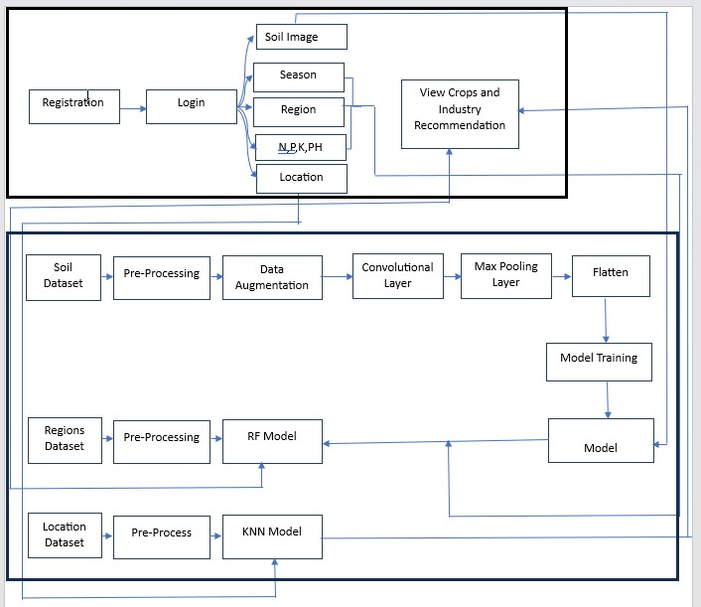

Figure 3.1: Block diagram

* 1. **ASSUMPTIONS AND DEPENDENCIES**
* **Assumptions: -**Reliable identification and classification of speech it involves hu- man judgment of several factors and a combination of experiences, a decision support system is desirable in this case.
* **Dependencies: -**Algorithm is using structured data from online platform. To the best of our knowledge, none of the existing work focused on both data types in the area of big data analytics. It is reducing violence is using giving accurate diagnosis.
  1. **FUNCTIONAL REQUIREMENTS**
     1. **System Feature 1(Functional Requirement)**
        + Soil Photo
        + Region/place
        + Location/address
     2. **System Feature2 (Functional Requirement)**

Database Requirements:

* + - * Database –SQLite3
  1. **EXTERNAL INTERFACE REQUIREMENTS**
     1. **User Interfaces**

Python

Python interface is being actively developed right now. There are many algorithms and many functions that compose or support those algorithms. Open CV is written natively in C++ and has a template interface that works seamlessly with STL containers.

Image Processing

Read and Write Images. Detection of images and its features. Detection of shapes like Circle, rectangle etc. in an image, Detection of coin in images. Text recognition in images. e.g., Reading Number Plates. Modifying image quality and colors.

* + 1. **Hardware Interfaces**
       - To run our project, we required a hardware system which is feasible for our project like Intel I3 processor, 2 GB RAM, 20GB Hard disk. We also need standard keyboard, Mouse, LED Monitor.
    2. **Software Interfaces**
       - The system can use Microsoft as the operating system platform. System also makes use of certain GUI tools. To run this application, we need PyCharm and above as python platform. To store data, we need SQLite database.
    3. **Communication Interfaces**

1. Crop recommend System
2. User-soil image data set item 3] Pre-processing unit
3. Classified answer in the form of predictions 4] Open-CV for image process
   1. **Nonfunctional Requirements**
      1. **Performance Requirements**

**Performance**: Performance of our system fast as compare other system and response time is quick.

**Availability**: Availability of data is also requirement for performing any operations.

**Maintainability**: System is reliable for crop prediction.

**Security**: In this system user information is store in the form of audio, so our system is secure.

**Usability**: This system is very useful in assistive tool for public sector.

* + 1. **Safety Requirements**

This study is carried out to check the economic impact that the system will have on the organization. The amount of fund that the company can pour into the research and development of the system is limited. The expenditures must be justified. Thus, the developed system as well within the budget and this was achieved because most of the technologies used are freely available.

* + 1. **Security Requirements**

The main thing in our system is, we have to provide end to end security for user and provider signs by using proper authentication login credentials. User has been given rights to upload speech and only view the results. The system is fully secure as well as eco- friendly. We implemented this system by considering security aspects so we divide our system into four different modules for achieving integrity.

* + 1. **Software Quality Attributes**

**Capacity**: Capacity of project according to data it is very less. **Availability**: Proposed system will available on python application. **Reliability**: System is reliable for crop prediction.

**Security** User when login to system that time users mail id and password match accurately.

* 1. **System Requirements**
     1. **Database Requirements**
        + Database - SQLite
     2. **Software Requirements**

Operating System - Windows Front End - Python3x Database -SQLite3

IDE - PyCharm

* + 1. **Hardware Requirements**
       - Processor - I3
       - Speed - 1.1 GHz
       - RAM - 2 GB (min)
       - Hard Disk - 20 GB
       - Floppy Drive - 1.44 MB
       - Camera -System camera
       - Key Board

- Standard Windows Keyboard

* + - * Mouse - Two or Three Button Mouse
      * Monitor - SVGA
  1. **Analysis Models: SDLC Model to be applied**

Waterfall Model – The waterfall model is a sequential model that is used in the software development processes, where the process is seen flowing steadily downwards through the phase of Requirement Gathering and Analysis, System Design, Implementation, Testing, Deployment and Maintenance.

1. Requirement analysis:

Here requirements are gathered means which kind of dataset is required. Then what are functional requirement of system. Document is prepared, and then use cases are designed. In our system we gather all information of Admin and user and functionality of each module.

1. System Design:

In this stage, hardware and software requirement to design the system is decided. It uses above mentioned hardware and software requirements. We design the of Admin and user module. Design the according to functionality of each module.

1. Implementation: In this stage, system is developed module wise. In this system consist of mainly 2 modules That is
2. Admin
3. User
4. Testing

In this stage, all developed software’s are installed and they are tested in different ways against the system requirements. In this stage we check all this module is working properly or not with proper authentication.

1. Deployment

In this deployment stage we deployed the new functionality of each module like dataset gathering, pre-processing, feature extraction and classification. We deploy all system with proper functions.

1. Maintenance:

According to software’s new version and their use, they need to be updated., some predefined machine learning libraries need to be used. This system is easy to maintain

* 1. **System Implementation Plan**

|  |  |  |
| --- | --- | --- |
| SR NO. | TASK | LABOUR HOUR/DAYS |
| 1. | Topic Selection | 2 Weeks |
| 2. | Feasibility Study | 1 Week |
| 3. | Project Design | 2 Weeks |
| 4. | Develop Functional Specifications | 10 Days |
| 5. | Develop System Architecture | 2 Weeks |
| 6. | Develop Detailed Design Specifications | 2 Weeks |
| 7. | Data Collection and Environment Setup | 2.5 Weeks |
| 8. | Project Development | 10 Weeks |
| 9. | Perform Module Integration | 3 Weeks |
| 10. | Perform Testing | 3 Weeks |
| 11. | Post Project Review | 1 Week |

Table 3.1: Project Estimate

* 1. **Data Flow Diagrams**
     1. **Data Flow Diagram Level-0**

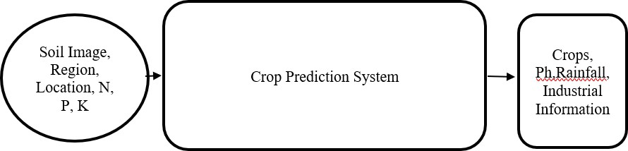

Figure 3.2: DFD level-0

* + 1. **Data Flow Diagram Level-1**

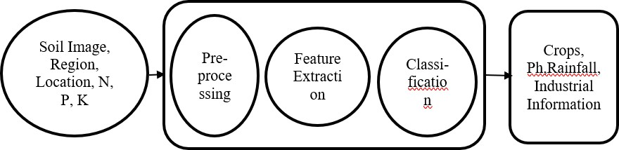

Figure 3.3: DFD-1

* + 1. **Use Case Diagrams**

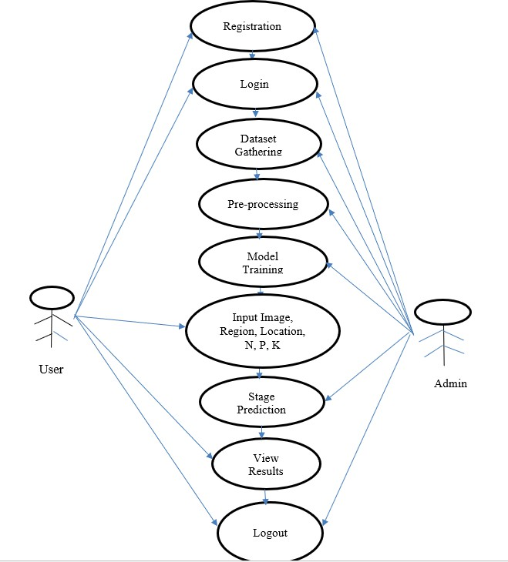

Figure 3.4: Use Case Diagram

* 1. **Class diagram**

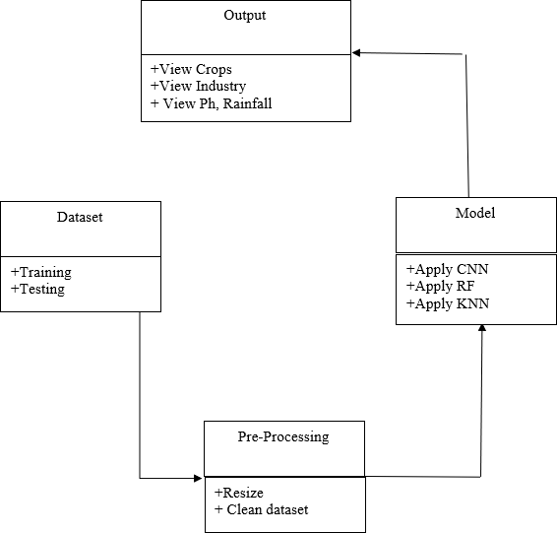

Figure 3.5: Class diagram

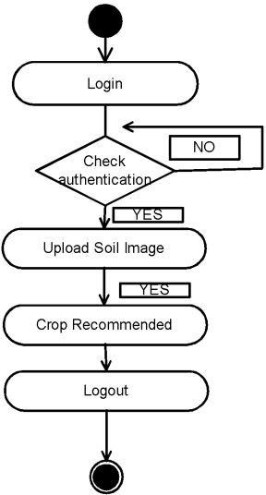

Figure 3.6: Activity diagram

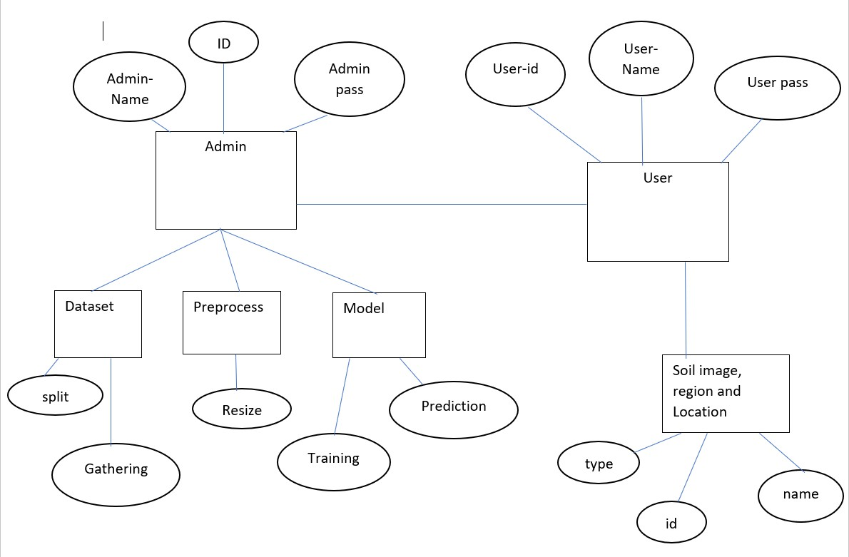

Figure 3.7: ERs diagram

**CHAPTER 4 SIMULATION AND TESTING**

## Software Testing

## Type of Testing

* + - Gone are the days when solely managers would huddle around a whiteboard dis- cussing risks, issues and time lines. Instead, it is now common place to see cross- team collaboration on every area of the project, testing included. It is suitable for anybody who is interested in learning how to interactively design and discuss a set of test ideas that may later be performed by a person, using automation or a mixture of both. Some previous exposure to software testing is beneficial, but no prior knowledge of test design techniques or facilitation is required. Non-testing roles welcome.
    - Initially we will use Django platform for every module of the program.
    - Testing the real time image as input etc.
    - Randomizing input image in case edge case is missed
    - Second phase of testing will be integration testing. Once the functionality is tested, we will need to do performance testing especially on the GUI.

## Test cases & Test Results

* + - Testing GUI input buffering, load tests, etc.
    - Testing the entire system as a whole single unit
    - Making sure all the individual modules function are working when combined.
    - GUI testing can be done alongside integration phase of the testing plan.
    - Consists of making sure GUI is responsive, functions properly (buttons do the correct actions.
    - Tools like PyCharm, spyder, Django helps in Testing. These tools gave us following test results.

**CHAPTER 5**

**RESULT ANALYSIS, CONCLUSION**

## Algorithm Details

### 5.1.1 CONVOLUTIONAL NEURAL NETWORK

In this proposed research paper Convolution Neural Network will be used for feature extraction. CNN can fetch exact features from the image data, rather than taking the features one by one. Generated weights are extracted from the different layers of CNN such as convolution layers, poo ling layers, activation layer and fully connected layers. Convolution layer is the key role of this network, which does the extraction of the features from the training image data.

* + - Convolution The principle utilization of the Convolution activity if there should be an occurrence of a CNN is to recognize fitting highlights from the picture which goes about as a contribution to the primary layer. Convolution keeps up the spatial interrelation of the pixels This is finished by fulfillment of picture highlights utilizing miniscule squares of the picture. Convolution equation. E very picture is seen as a network of pixels, each having its own worth. Pixel is the littlest unit in this picture grid. Allow us to take a 5 by 5(5*5) framework whose qualities are just in twofold (for example 0 or 1), for better agreement. It is to be noticed that pictures are by and large RGB with upsides of the pixels going from 0 - 255 i.e., 256 pixels.
    - ReLU follows up on a rudimentary level. All in all, it is an activity which is applied per pixel and overrides every one of the non-positive upsides of every pixel in the component map by nothing.
    - Pooling or sub-sampling Spatial Pooling which is likewise called subsampling or down sampling helps in lessening the elements of each element map yet even at the same time, holds the most important data of the guide. Subsequent to pooling is done, in the long run our 3D element map is changed over to one dimensional component vector.
    - Fully Connected layer the yield from the convolution and pooling activities gives noticeable highlights which are removed from the picture. These highlights are then used by Fully Connected layer for consigning the info picture into various classes predicated on the preparation dataset.

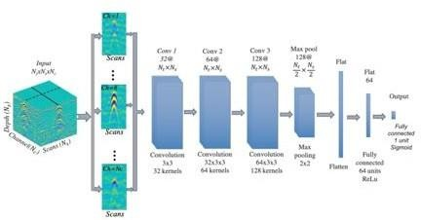

Figure 5.1: CNN diagram

### Algorithm 2

2. Random Forest

A conflicting woods locale is a man-made understanding strategy used to oversee co- ordination and fearlessness concerns. It utilizes pack understanding, a framework that consolidates a few classifiers to manage any outcomes relating to convoluted difficulties. Different choice trees are incorporated into a capriciously backcountry gauge. By pulverizing or bootstrapping amounting to, tree choice for the extravagant forest region area evaluation is ready. Squeezing is a get-together meta-assessment that makes arrangements with the precision of human grasping evaluations. The end is fanned out by the assessment’s (inconsistent woodlands) suppositions for the choice trees.

It makes expectations by utilizing the typical or mean of the outcomes from various trees. The number of trees that are planted decides the result’s accuracy as we showed in figure.

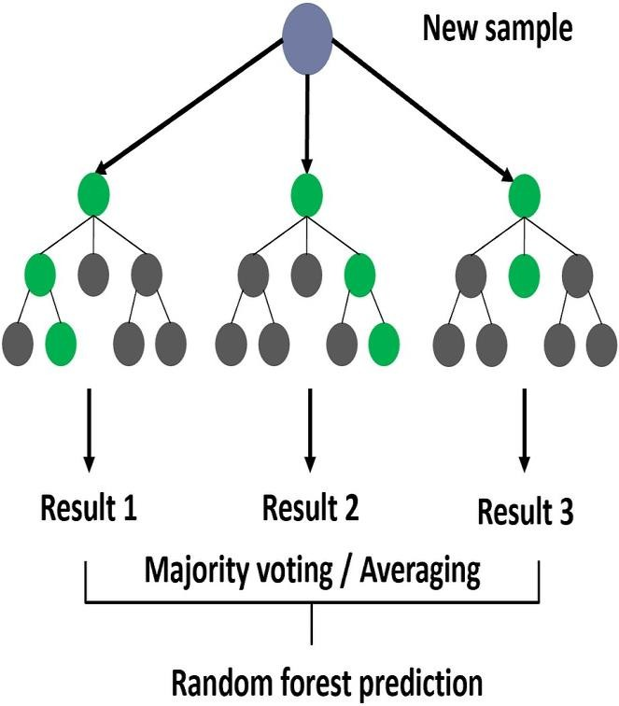

Figure 5.2: Random Forest diagram

#### 5.1.3 Algorithm 3

3. KNN

A refinement of the k-NN characterization calculation is to gauge the commitment of every one of the k neighbors as indicated by their distance to the inquiry point, giving more prominent load to nearer neighbors. The KNN classifier recommending the emergency clinic subtleties for infection dependent on the closest distance.

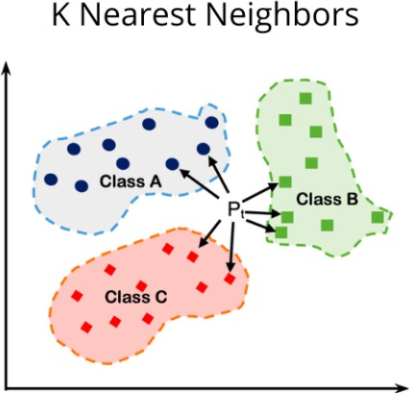

Figure 5.3: KNN diagram

d=((x2-x1)²+(y2-y1)²) d=distance

x1, x2, y1, y2 = data points

## Results Analysis

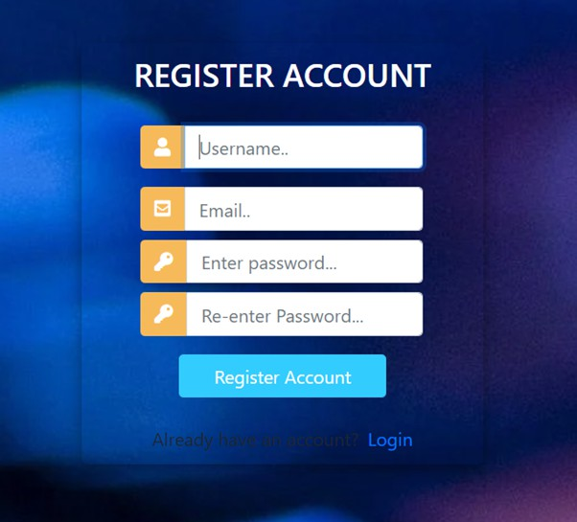Figure 5.4: Registration Form

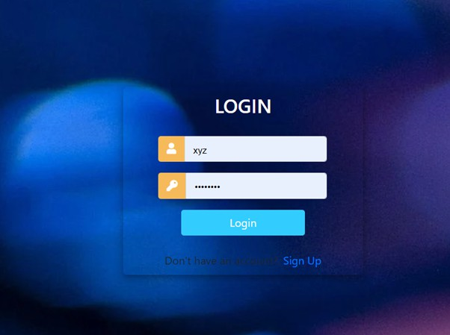

Figure 5.5: Login Form

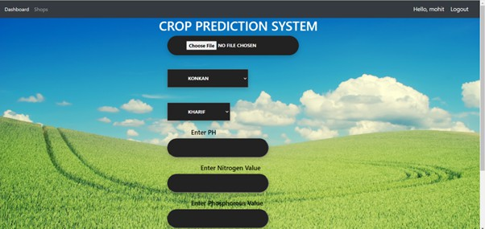

Figure 5.6: Home Page

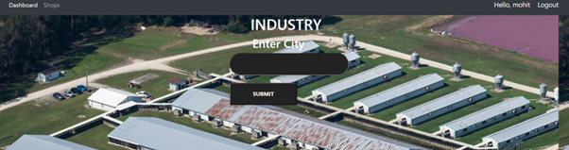

Figure 5.7: Home Page



Figure 5.8: Result Page

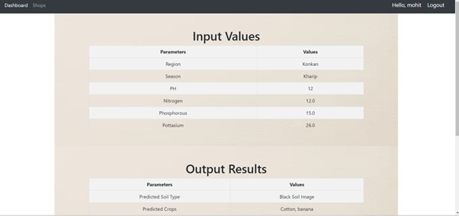

Figure 5.9: Result Page

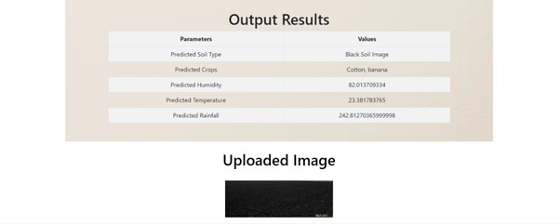

Figure 5.10: Result Page

## Conclusions

In this research, a wide range of strategies needs to investigate in machine Learning and deep learning tailored for soil classification and recommendation of crops. In this paper, we proposing an CNN model developed from ConvNet. We are using CNN model for soil image classification, which has four classes (Alluvial, Clay, Red, Black) images classification problem. Based on every class we are suggesting the crops, Ph, Rainfall, Temperature by using random forest. Also, we, are going to recommend industrial information to farmer for selling crop. With this system we will provide a user-friendly application that covers aspects like name of that crop recommendation. Using the challenging database in which the soil images are taken. At the front end, i.e., the User Interface, the input will be the soil image by the user. The output will be in the form of crop recommendation. In this project we achieve 98.23% accuracy using convolutional neural network.

# REFERENCES

1. Madhuri Shripathi Rao1, Arushi Singh1, N.V. Subba Reddy1 and Dinesh U Acharya “Crop prediction using machine learning” Journal of Physics: Conference Series AICECS 2021.
2. Sonal Agarwal1 and Sandhya Tarar2 “A HYBRID APPROACH FOR CROP YIELD PREDICTION USING MACHINE LEARNING AND DEEP LEARNING ALGORITHMS”

Journal of Physics: Conference Series CONSILIO 2020.

1. Pavan Patil1, Virendra Panpatil2, Prof. Shrikant Kokate3 “Crop Prediction System using Machine Learning Algorithms”. International Research Journal of Engineering and Technology (IRJET) Volume: 07 Issue: 02 | Feb 2020.
2. Surili Agarwal, Neha Bhangale, Kameya Dhanure, Shreeya Gavhane, V.A.Chakkarwar, Dr. M.B.Nagori “Application of Colorimetry to determine Soil Fertility through Naive Bayes Classification Algorithm” 9th ICCCNT 2018 July 10-12, 2018, IISC, Bengaluru.
3. Sk Al Zaminur Rahman, Kaushik Chandra Mitra, S.M. Mohidul Islam “Soil Classification using Machine Learning Methods and Crop Suggestion Based on Soil Series” 2018 21st International Conference of Computer and Information Technology (ICCIT), 21-23 December 2018.
4. Dhanush Vishwakarma “Crop Prediction using Machine LearningApproaches” In- tri-national Journal of Engineering Research Technology (IJERT).
5. Rageena P.M et al. “Agriculture Crop Prediction System Based on Meteorological Information” International Journal of Control Theory and Applications ISSN: 0974- 5572.
6. Prof. D.S. Zingade, Omkar Buchade, Nilesh Mehta, Shubham Ghodekar, Chandan Mehta “Crop Prediction System using Machine Learning”.
7. Ashwani Kumar Kushwaha, Swetabhattachrya “crop yield prediction using agro algorithm in Hadoop”.
8. Girish L, Gangadhar S, Bharath T R, Balaji K S, Abhishek K T “Crop Yield and Rainfall Prediction in Tumakuru District using Machine Learning”.
9. Rahul Katarya, Ashutosh Raturi, Abhinav Mehndiratta, Abhinav Thapper “Impact of Machine Learning Techniques in Precision Agriculture”.
10. Pijush Samui, Venkata Ravibabu Mandla, Arun Krishna and Tarun Teja “Prediction of Rainfall Using Support Vector Machine and Relevance Vector Machine”.
11. Himani Sharma, Sunil Kumar “A Survey on Decision Tree Algorithms of Classification in Data Mining”.
12. Pavan Patil, Virendra Panpatil, Prof. Shrikant Kokate “Crop Prediction System us- ing Machine Learning Algorithms”.
13. David B. Lobell and Marshall B. Burke (2010) On the Use of Statistical Models to Predict Crop Yield Responses to Climate Change, Elsevier,1.

# APPENDIX

**Appendix A:** Problem statement feasibility assessment using, satisfiability analysis and NP Hard, NP-Complete or P type using modern algebra and relevant mathematical models.

##### Title:

Project problem statement is feasibility assessment using NP-Hard, NP-Complete or satiability issues using modern algebra and relevant mathematical models.

##### Theory:

##### What is P?

* + P is set of all decision problems which can be solved in polynomial time by a deterministic.
  + Since it can be solved in polynomial time, it can be verified in polynomial time.
  + Therefore, P is a subset of NP.

##### What is N?

* + "N" in "NP" refers to the fact that you are not bound by the normal way a computer works, which is step-by-step. The "N" actually stands for "non-deterministic". This means that you are dealing with an amazing kind of computer that can run things simultaneously or could somehow guess the right way to do things, or something like that.
  + So, this "N" computer can solve lots more problems in "P" time - for example it can just clone copies of itself when needed.
  + So, programs that takes dramatically longer as the problem gets harder (i.e., not in "P") could be solved quickly on this amazing "N" computer and so are in "NP".
  + Thus "NP" means "we can solve it in polynomial time if we can break the normal rules of step-by-step computing".

##### What is NP?

* + "NP" means "we can solve it in polynomial time if we can break the normal rules of step-by-step computing".

##### Project Status:

**Problem:** The main problem how to recommend crops and Industry Using AI.

##### Solution:

In the Feasibility Study stage, the assigned project is analyzed, then information about the project participants is collected, and the requirements for the system are gathered and analyzed. During the Feasibility Study stage, the project’s goals, parameters and restraints are agreed and a conceptual problem solution is prepared. In this system we can predict crops, technique over data after allowing the technique, user can upload image. If user upload image and provide location are found in the system. All this procedure for searching crops and industries is possible in real time, so this project is NP-Complete.

##### The project is NP-Complete. Mathematical Model System Description:

* + **Mathematical Model:** Let us consider S as a system for automatically recommends vehicle to customer. S={F,I,O,e,ϕ}

#### INPUT:

Identify the inputs F= f1, f2, f3 , fn— F as set of functions to execute

commands.

* + Let U be the Set of System.
  + U= Sk1,Sk2,SK3,R1,R2,D

Where Sk1,Sk2,SK3,R1,R2 are the elements of the set.

* + Sk1=Upload image
  + SK2= Provide location
  + R1=Get Accurate result
  + R2= Error in the accessing of the system

##### A] Mapping Diagram Set Theory

S={s, e, X, Y,ϕ}

Where,

s = Start of the program.

1. Log in with webpage.
2. Upload image and location which we want to predict crops

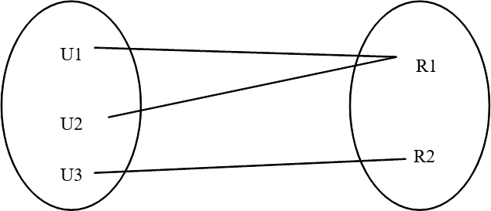

Figure 5.3: Mapping Diagram

X = {SK1,SK2..SKn}

X = Input of the program.

Where, SK1,SK2..SKn= image, Location Y = Output of the program.

e = End of the program.

Proper name of file which is store in local **Failures and Success conditions:- Success:**

* 1. We get crops which want to search.
  2. We get accurate file.

##### Failures:

1. Huge database can lead to more time consumption to get the information.
2. Hardware failure.
3. Software failure.